Angular supports two ways forms and validations:

1. Template Driven Forms
2. Reactive Forms

Template Driven Forms or TDF, is achieved by driving all the business logic using in-built attributes (novalidate, #ref, ngForm, ngSubmit, ngModel, required, minlength, maxlength, pattern) inside **mark-up** (.html or templates)

This generates the following structure at run-time: ngForm instance is created and multiple FormControl instances created and these FormControl instances are associated with ngForm instance

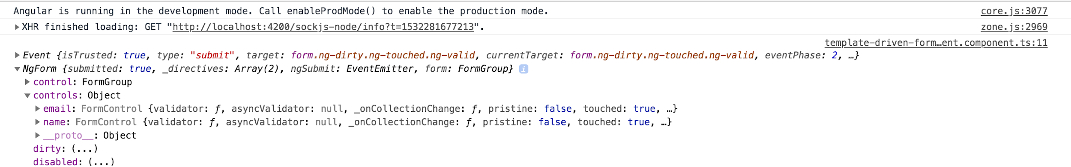

Form has one to many form controls

Each form control has zero to many validators(required, minlength, maxlength, pattern)

**Form is considered validated if and only if all the form controls are validated!**